THE OBSERVATION OF THE FEEDING BEHAVIOUR IN *AEQUOREA* SP. SUFFERING FROM JELLYFISH EVERSION SYNDROME

**1.0: INTRODUCTION**

*Aequorea* sp. was found in the sandy inner reef zone of Heron Island, Queensland, Australia.

After much research, the captured jellyfish was identified as belonging to the genus *Aequorea*. Unfortunately, *Aequorea* sp. could not be identified to a species level.

Due to its classification as a Leptothecatae hydrozoan, there are several characteristics that *Aequorea* sp. exhibited. These included a shallow, saucer-like shape, a cross-striated coronal muscle in the vellum and a tubular manubrium (Ruppert *et al.,* 2004). Also, there was a lack of gastrodermal canals in the vellum (Ruppert *et al.,* 2004). Leptothecatae hydrozoans typically also have a theca present in the hydroid stage of the life cycle (Ruppert *et al.,* 2004). During observations under a dissecting microscope, *Aequorea* sp. was found to have forty tentacles. This could not be used as a tool for further classification due to uncertainties regarding whether or not it was fully developed. The nematocysts, while present, did not appear to have an effect on humans.

In general, medusae are opportunistic feeders. They rely upon constant swimming to being them into contact with their prey. Prey brushing against the tentacles of the jellyfish causes nematocysts (or stinging cells) to fire, resulting in the death of the captured prey. The prey is then moved to the manubrium (or mouth) where it is transferred into the gastrodermal cavity (or stomach) for digestion to take place. This is the common method of feeding in all medusae.

During observations in the field before capture, *Aequorea* sp. was found to have a strange structure on top of its bell. Trying to identify this structure caused a large degree of confusion to the staff and myself. However, after observations made on the feeding behaviour of *Aequorea* sp., this structure was identified to be a manubrium.

After copious amounts of research, it was discovered that *Aequorea* sp was suffering from jellyfish eversion syndrome. This is further explained below.

**2.0: COLLECTION & TANK HABITAT**

*Aequorea* sp. was collected at 6:30am during a reef walk. It was placed in a holding tank directly after capture in order to limit stresses placed on the animAll other organisms (aside from a fire coral that proved to dangerous to move) were removed from the tank.

At 11:30am, salps were collected during a snorkel and were placed in the tank with *Aequorea* sp. on a whim. *Aequorea* sp. was checked at multiple times during the day.

**3.0: FEEDING BEHAVIOUR**

At exactly 1:27pm, *Aequorea* sp. was observed making contact with a salp via its manubrium. The jellyfish continued to engulf the salp through the manubrium on top of its bell. At 1:35pm, the entire salp had been ingested, causing the bell to expand quite significantly to accommodate the salp. At 13:57, the salp had been digested quite a lot and the size of it had decreased significantly. The size of the manubrium also reduced to its original size. From here, *Aequorea* sp. remained relatively inactive. At 3:21pm, the manubrium started to expand again in preparation for expelling the salp.

At 5:02pm, the salp was completely expelled via the manubrium. *Aequorea* sp. returned to its original size.

It should also be noted that during observations, it was discovered that *Aequorea* sp. was able to control the movement of the manubrium.

**4.0: EXPLAINATION OF FEEDING BEHAVIOUR**

There is not a lot of information surrounding jellyfish eversion syndrome in the literature. The only documented cases of jellyfish eversion syndrome are in captive scyphozoans (Freeman *et al.,* 2009). Eversion syndrome is apparently a common occurrence in captive jellyfish (Freeman *et al.,* 2009), however there are no records of it having occurred *in situ*. The pathogenesis of eversion syndrome remains unclear (Freeman *et al.,* 2009).

The histologic examinations of jellyfish in the paper published by Freeman *et al.,* (2009) found that muscle within the jellyfish degenerated in those suffering from eversion syndrome. However, it was unclear as to whether this muscle degeneration was the cause or the result of eversion syndrome (Freeman *et al.,* 2009). The pictures taken by Freeman *et al.* (2009) can be found in the appendix of this report for comparison to those taken of *Aequorea* sp. on Heron Island (see appendix).

The study performed by Freeman *et al.* (2009) determined that there were two potential causes for eversion syndrome in jellyfish. Firstly, damage to mesoglea fibers could have caused the conformational changes that are associated with eversion syndrome (Freeman *et al.,* 2009). Secondly, the interruption of nervous conduction by external factors such as water temperature could have been responsible for the eversion of the jellyfish (Freeman *et al.,* 2009). These two factors could have played a role in the eversion of *Aequorea* sp. prior to capture, however, this cannot be validated because there have been no records of jellyfish eversion syndrome in the wild.

Unfortunately, due to a lack of information, little is known about jellyfish eversion syndrome. As a result, not many conclusions can be drawn about *Aequorea* sp. other than the fact that it is showed one-of-kind eversion syndrome outside of captivity. More research is required on these unusual jellyfish and their lifestyles.

**5.0: REFERENCES**

Freeman, K.S., Lewbart, G.A., Robarge, W.P., Harms, C.A., Law, J.M., & Stoskopf, M.K. (2009). Characterization of eversion syndrome in captive Scyphomedusa jellyfish. *American Journal of Veterinary Research,* 70(9), 1087-1093.

Ruppert, E.E., Fox, R.S., & Barnes, R.D. (2004). *Invertebrate zoology: a functional evolutionary approach*. California, USA: Brooks/Cole, Cengage Learning.

**6.0: APPENDIX**

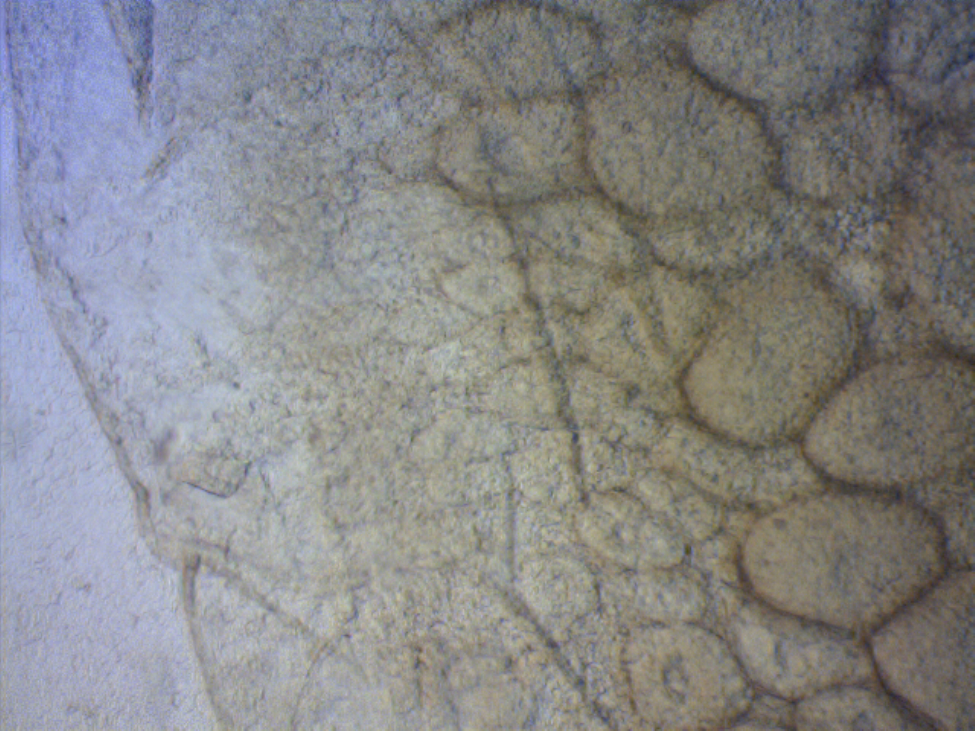

**Figure 4.1:** Microscopic view of *Aequorea* sp. body mass showing a case of possible muscle degerneration (red rectangle). Photo taken at Heron Island by Katie Maling.

The following pictures are from the 2009 study by Freeman *et al.*

